Network Designing (Report)

# Executive Summary:

This report is written in the context of the newly established cooperative society named Smart Farmer’s (SF)who are looking to design a network for their society. The Smart Farmer’s cooperative society is situated in the Queensland, Australia. The SF is conducting their business operation from the small office situated in the Rockhampton city of the Queensland state. The aim of this society if to increase the yield of the farmer members and looking to sell the harvest directly to the customer as quickly as possible without any kind of third-party intervention. The society is trying to sell the crops at the lower price in comparison to the big supermarkets. The SF is having six distribution centers, their own trucks, and seven distribution vehicles are allocated to each center’s. The SF is having its own propriety software so when the customer places the order using the web or App interface it will be redirected to their own application. Also, this software is fully automated and helps the farmers to provides the information like how much and which fertilizer they should use for which crop and other farming related suggestions like real-time guidance. Also, from the smart IoT devices it collects the data and gives the information like soil temperature, moisture content, rainfall, etc., The SF is also providing the banking facilities to their member farmers as well and farmers can use the SF forum for any queries related to the system or with farming.

Now coming to the technical aspects, the SF is expecting the 24/7 internet connectivity as they want us to design a network for at the minimum budget requirements. So, our team will design a logical and physical network design for them so they can conduct their operation is an efficient manner. So, this report contains all the information that is needed to design a network like designing model and diagrams with top-down approach, network security mechanisms by taking care of the information security, recommendation of networking hardware devices to be used with the appropriate version of the software, etc. so design a robust network for them.

To summarise we are going to design a network for the SF cooperative society so they can run their business operation on it. In network design we are going to adapt the top-down network methodology which includes physical and logical network design with the appropriate IP addressing and naming.

1. Table of Contents

1. Executive Summary: 2

3. Project Goal: 5

4. Project Scope: 5

4.1 In scope: 5

4.2 Out of Scope: 5

5. Business Goals and Constraints 5

5.1 Smart Farmers Business Goals: 5

5.2 Business Constraints: 6

6. Technical Goals and Trade-offs: 6

6.1 Smart Farmers Technical Goals: 6

6.2 Tradeoffs: 6

7. Table of User Communities, Data Stores, Network Applications and Traffic Flows: 7

7.1 User Community Table: 7

7.2 Data Stores Table: 8

7.3 Network Application Table: 9

8. Smart Farmers Network Diagram: 10

9. Logical Network Diagrams: 10

9.1 Justification of logical network design: 10

Figure 1: Traffic flow diagram of Smart Farmers 11

Figure 2: Network Topology Branch Office Diagram 12

Figure 3: Head Office Overall Network Topology 13

10. Addressing and Naming 13

10.1 Rockhampton Subnet Addressing and Description: 13

11. Switching Protocols: 15

11.1 Routing Protocol: 15

11.2 Switching Protocols: 15

11.3 Security Mechanisms: 16

12. Physical Network Diagrams: 17

13. The table of networking & communication devices and applications required, including the cost of each of them, the IP addresses, the product numbers as well as the approximate total cost: 18

13.1 Total Costing: 18

14. Explanation and justification of the networking & communication devices and applications required: 19

15. Test Plan to test newly designed network: 20

15.1 Test objective and Acceptance criteria: 20

15.2 Types of tests need to be done: 20

15.3 Network equipment’s and resources required for the testing: 20

15.4 Testing done using Test Script: 20

15.5 Timeline and milestones for the project testing: 21

16. Detail Test plan script: 21

17. Recommendation: 22

18. Conclusion: 22

19. References: 22

# Project Goal:

The goal of this project is to design a network using top-down methodology for the Smart Farmer’s co-operative society as they need to know what their network requirement should be so they can conduct an easy-going business operation. **We are trying to design a cloud-based network for SF to satisfy their requirements of low budget, high availability, and network performance with high security to satisfy their business goals**. After finishing the network designing the of this project the SF will be able to use all the functionalities like collecting and providing real-time data from the field to the farmers, online banking with the high secure connectivity can be done can be provided to members farmers, the SF proprietary application probably will not face any down-time, but if it happens then back-up server functionality is provided and it will automatically be activated and they can give the satisfaction to farmers and customers by proving an uninterrupted services. The truck driver’s location and customer order tracking can be done by their mobile, or web interface, etc., functionality can be achieved. Basically, the designed network will be capable of handling all this functionality.

# Project Scope:

## 4.1 In scope:

The scope of this project is to design a network for the SF cooperative society situated in Queensland, Australia. They are looking to help their member farmers by assisting them to sell the crops as soon as possible with the lesser price directly to the customers with any third-party intervention. Also, they are looking to provide the uninterrupted services to their member farmers and customers, like they have the real-time data coming from the IoT devices installed on the farm fields, online banking faculties, truck driver’s location detection, etc., for that they require good bandwidth, high security to satisfy all the needs. So, for this network design will help to achieve their goal by hosting and working on the network applications. Also, this new system will allow customers to place an online order using the SF web or app interface.

## 4.2 Out of Scope:

Here our network design team is not going to test the network at the physical site, also the network installation and the onsite testing is not our responsibility. Also, the business goals which are not mentioned cannot be implemented so no extra work is there. We are bound to thoroughly follow the business goals asked by the SF cooperative society chairperson.

# Business Goals and Constraints

## **Smart Farmers Business Goals:**

A business goal is an essential part of a business. The goals will serve as guidelines for the project, and they will be the main part of the business requirements. Also, the business goal will provide outcomes of the network design if it helps the organization or not.

1. Increase the yield of SF member farmers to sell the harvest directly to the customer.
2. Sell the crops at a lower price compared to giant supermarkets in the state.
3. The new system will allow customers to place an order through the web or application.
4. Store many products in the database and setting the minimum delivery time for each order.
5. A separate application for farmers and customers. Truck drivers have an automated delivery process that is connected to the SF and Farmers.
6. Allow farmers to order the needs of farms through the network system.
7. Implementing automated data gathering (24/7) by using IoT on the SF application interface.
8. Include a discussion page on the web to allow farmers to ask a question.
9. Providing member farmers to use the Online net banking facilities like other banks.

## **Business Constraints:**

1. The business constraint that will affect the implementation of the new system of SF is the budget.  It is possible to include limiting restrictions within a scenario by using business constraints and the requirements can be predicated on current business contracts, purchasing guidelines, or business regulations (Angelino 2021). The bellow areas are affected by the budget constraints.

* Software Cost
* Maintenance
* Testing
* Training
* Implementation.

# Technical Goals and Trade-offs:

## **Smart Farmers Technical Goals:**

(Openheimer, P.et al., 2011) stated that, “Typical technical goals include scalability, availability, network performance, security, manageability, usability, adaptability, and affordability”.

1. Make the web server available for all the farmers to increase the capability of uploading the harvest of crops in the system.
2. Collect real-time prices of crops in supermarkets to provide lower prices on the produce.
3. Increase network capability to collect real-time information about the crops and, increase network availability to allow the system to run the rest of the day to allow users to access the app and website anytime.
4. Increase data storage to store a large number of products and users in the system.
5. Increase network bandwidth to accommodate online bank access to the system.
6. Increase the web and app availability and manageability for customers to easily navigate.
7. Installing security programs on the server to prevent cybercriminal access and to help protect farmers’ and customers’ details.
8. Needs high security and 24/7 internet connectivity

## **Tradeoffs:**

Providing the trade-offs for an organization will come with a big cost to providing good-performing materials for the system (Openheimer, P.et al, 2011). The parameters that are crucial for the new system are those measured below in the trade-offs for Smart Farmers. Since it makes up most of the SF system, security, availability, and performance are of the utmost importance. The highest priority is network performance because the system will operate around the clock and need to run IoT to get real-time data about the facility and the plants. Like this, the system's security is crucial because the database contains information about each user, including their names and bank accounts. The new system's availability is particularly crucial because the database will be accessible from 6 different locations across Queensland. Applications will also be available for truck drivers, customers, and office personnel in addition to farmers.

|  |  |
| --- | --- |
| **Network Performance** | 40 |
| **Security** | 35 |
| **Availability** | 25 |
| **Total** | 100% |
|  |  |

# Table of User Communities, Data Stores, Network Applications and Traffic Flows:

* **A1:** The assumed six cities distribution center of the Queensland are: Brisbane, Gold Coast, Gladstone Central, Townsville, Rockhampton, and Cairns.
* **A2:** All the servers are deployed on the cloud with upfront payment method to get eligible for the instance discount to meet budget requirements.
* **A3:** All the applications used by the SF farmer’s cooperative society are client-server based.
* **A4:** As this is the just start-up of the SF so, around 500 members farmers were assumed, 42 truck drivers, 70 staff members and 1500 customers were assumed and according to that this application is designed further.

## User Community Table:

|  |  |  |  |
| --- | --- | --- | --- |
| User Community Name (Openheimer, P.et al, 2011) | Size of Community (Number of Users) | Location(s) of Community | Application(s) Used by Community |
| Farmers | 500 | Queensland | SF proprietary software (Web and App), Email, Banking Module |
| Truck Drivers | 42 | Queensland | SF proprietary software (Web and App), Email |
| Office Staff at each distribution centers | 70 | From Rockhampton and across other five centers only | SF proprietary software (Web and App)  Other necessary application like MS-Office, Antivirus, VPN, Operating system, etc. |
| Managers | 2 | From Rockhampton and across other five centers only | SF proprietary software (Web and App) user information’s and other applications like MS-Office, Antivirus, VPN, Email, Operating system. |
| Accountants | 2 | Rockhampton | SF proprietary software (Web and App), other necessary application like MS-Office, Antivirus, VPN, Email, User Account, and banking application. |
| Customers | 1500 | Queensland | SF proprietary software (Web and App interface), Email |
| SF board Members | 5 | Queensland | All software applications |
| Managing Director | 1 | Queensland | All software applications |

# Data Stores Table:

|  |  |  |  |
| --- | --- | --- | --- |
| User Community Name (Openheimer, P.et al, 2011) | Size of Community (Number of Users) | Location(s) of Community | Application(s) Used by Community |
| Farmers | 500 | Queensland | SF proprietary software (Web and App), Email, Banking Module |
| Truck Drivers | 42 | Queensland | SF proprietary software (Web and App), Email |
| Office Staff at each distribution centers | 70 | From Rockhampton and across other five centers only | SF proprietary software (Web and App)  Other necessary application like MS-Office, Antivirus, VPN, Operating system, etc. |
| Managers | 2 | From Rockhampton and across other five centers only | SF proprietary software (Web and App) user information’s and other applications like MS-Office, Antivirus, VPN, Email, Operating system. |
| Accountants | 2 | Rockhampton | SF proprietary software (Web and App), other necessary application like MS-Office, Antivirus, VPN, Email, User Account, and banking application. |
| Customers | 1500 | Queensland | SF proprietary software (Web and App interface), Email |
| SF board Members | 5 | Queensland | All software applications |
| Managing Director | 1 | Queensland | All software applications |

## Network Application Table:

CBR stands for constant bit rate which is used for traffic type depends on the time synchronization. Nrt-VBR is non-real-time variable bit rate traffic used for office applications. RT-VBR stands for real time variable bitrate for real time traffic streaming (Openheimer, P.et al, 2011).

|  |  |  |  |  |  |  |
| --- | --- | --- | --- | --- | --- | --- |
| Application Name (Openheimer, P.et al, 2011) | Type of Traffic Flow | Protocol(s) Used by Application | User Communities That Use the Application | Data Stores | Approximate Bandwidth Requirements | QoS Requirements |
| SF proprietary application | Client/  Server (accordin-g to A3) | HTTP/  HTTPS  request/  response | General application for farmers | Application Server | 2 Mbps | CBR |
| Real-time data access and sharing, banking facilities | Client/  Server | HTTP/  HTTPS request/  response | User Interface for Application | Web Server/ Database Server | 3.0 Mbps | Rt-VBR |
| DNS application | Client/  Server | DNS queries request/ response | Domain name resolution | DNS server | 0.5 Mbps | nrt-VBR |
| DHCP application | Client/  Server | DHCP request/  response | IP address allocation | DHCP Sever | 0.5 Mbps | nrt-VBR |
| Traffic Blocking / Iptables | Client/  Server | TCP | Security | Firewall | 1.0 Mbps | nrt-VBR |
| All applications the staff outside organization request to SF centers | Client/  Server | HTTPS | Encrypting and Decrypting network data | VPN Server | 2.5 Mbps | CBR |
| Other Applications like MS-office | Client/  Server | HTTP/  HTTPS request/  response | Office use Application | Application server | 2.5 Mbps | CBR |

# Smart Farmers Network Diagram:

The diagrams are the connectivity presentation of all the networks engaged in the whole process of the new network system of Smart Farmers. We have decided to provide 3 different diagrams where each one has its own purpose. Also, we use different networking topology for the network diagram that is composed of routers, switch, server switch, ISP, and each IP address of the users and devices.

# Logical Network Diagrams:

## Justification of logical network design:

As per the technical goals specified above for the Smart Farmers (SF), the logical network design is created to explain how devices will be communicated and connected using the logical IP addresses and how the information will flow in the network from the access point or from ISP to the last node. Here, Farmers can access the server to upload their harvest using the network, and they can also use the network to get real-time plant data by giving the appropriate bandwidth also internet banking facilities can be support with maintaining high security. Also, real-time order tracking and other office operation functionality can be achieved in an efficient manner.

Also, Logical diagram explains how the logical connectivity will work and how subnetting can done to make the efficient use of the IP addresses. Six routers are depicted in the graphic below as one of the defences against external attacks. The installation of firewalls is done to track the online malicious activities and to block them on finding it. Cloud services are used to incorporated into the network design to make network simpler and more resilient.

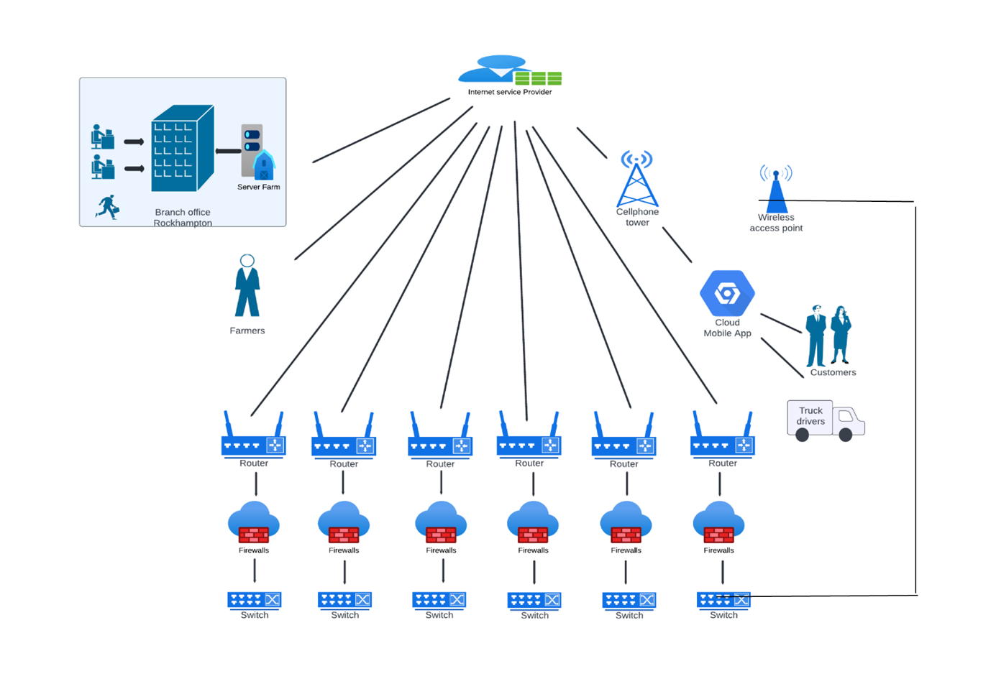

### Figure 1: Traffic flow diagram of Smart Farmers

**The figure below represents the network topology diagram of the Queensland’s branch office.**

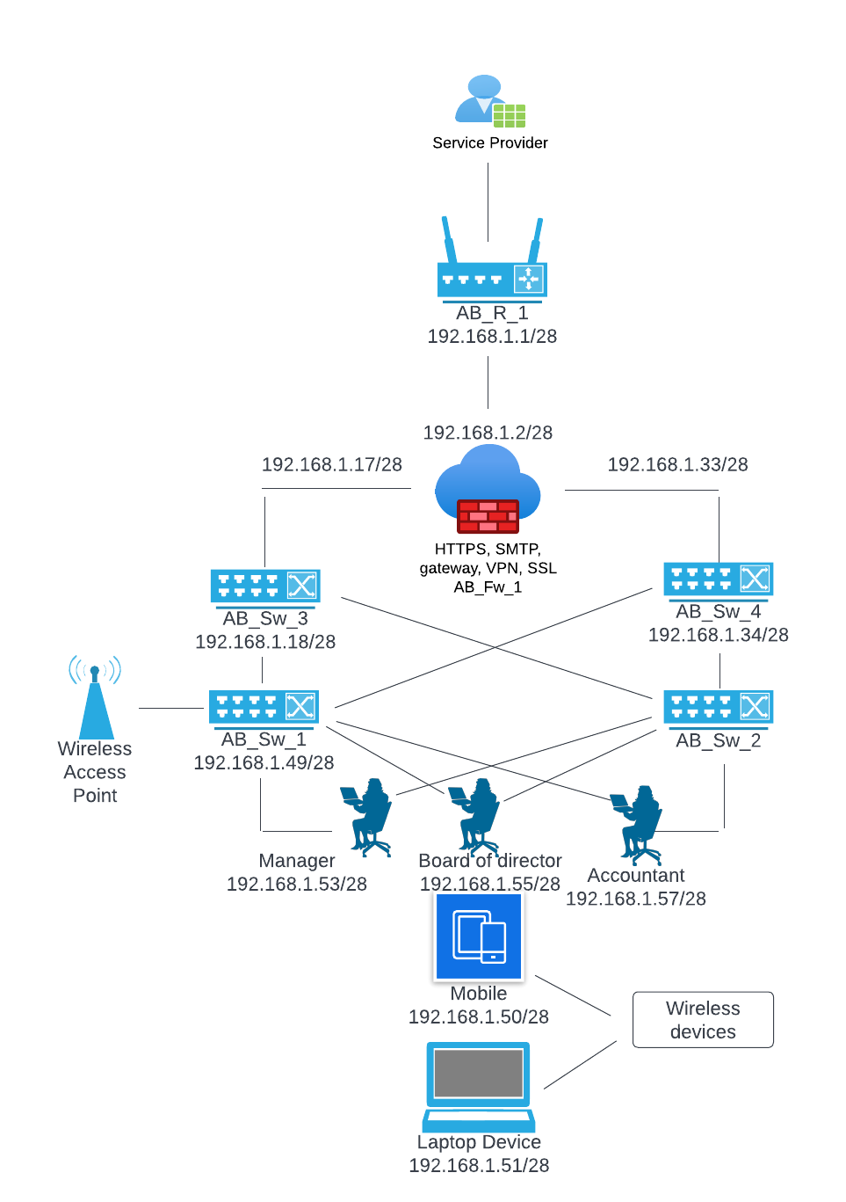

### Figure 2: Network Topology Branch Office Diagram

In the below figure our group decided to use top-down network design topology in designing the overall network diagram of Smart Farmers.

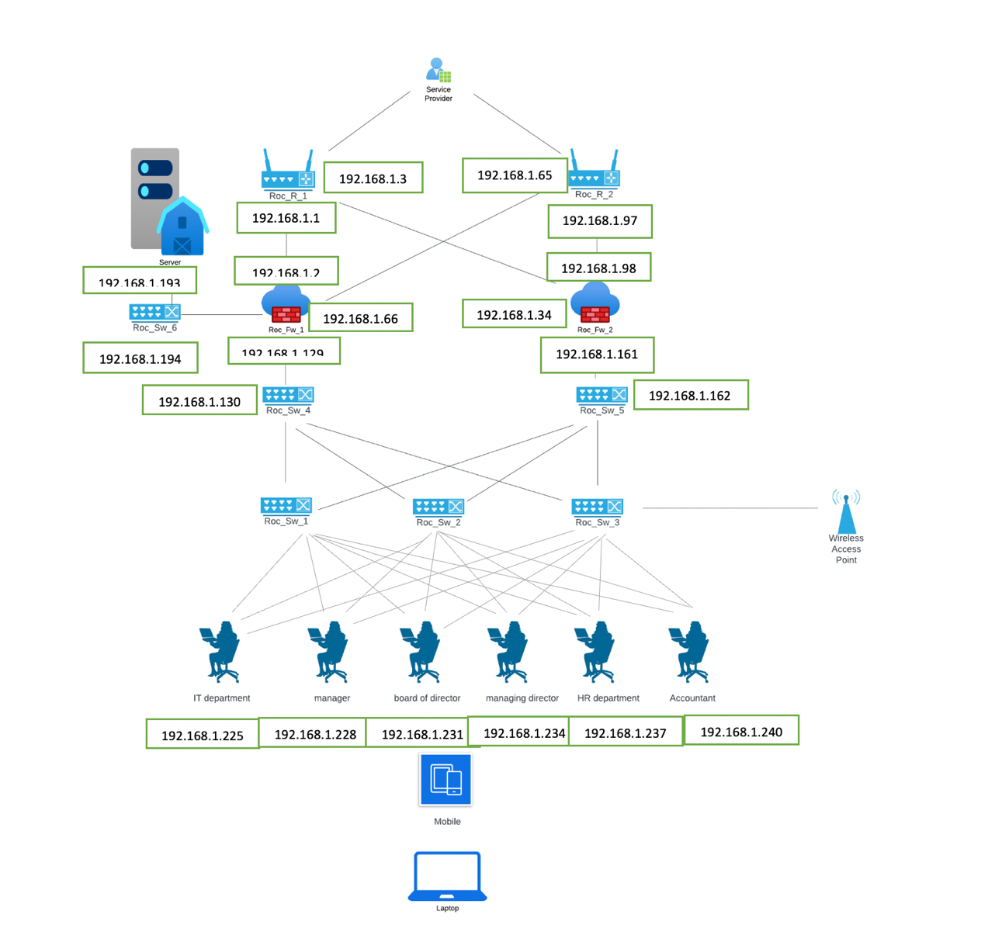

### Figure 3: Head Office Overall Network Topology

# Addressing and Naming

## Rockhampton Subnet Addressing and Description:

The addressing and naming scheme is follows as:

* Roc_R_X (x means values like 1,2,3, etc.) means Rockhampton router number 1(Roc_R_1).
* Roc_FW_X (x means values like 1,2,3, etc.) means Rockhampton Firewall number 1(Roc_FW_1).
* Roc_SW_X (x means values like 1,2,3, etc.) means Rockhampton Switch number 1(Roc_SW_1).
* For the addressing scheme for example 192.168.0.1/27 is selected so under this network range 30 hosts can be connected.

These are the naming and addressing schemes used below in the given table is used as per the network setup assumed from the Rockhampton as this is the head office of the SF and all the important business operation will be executed from here.

|  |  |  |  |  |  |
| --- | --- | --- | --- | --- | --- |
| Subnet | Subnet Description | Network Address | Usable host range | Broadcast address | Total number of usable hosts |
| Roc_R_1 to Roc_Fw_1 | Addresses between Rockhampton router 1 and firewall 1 | 192.168.1.0/27 | 192.168.1.1 - 192.168.1.30 | 192.168.1.31 | 30 |
| Roc_R_1 to Roc_Fw_2 | Addresses between Rockhampton router 1 and firewall 2 | 192.168.1.32/27 | 192.168.1.33 - 192.168.1.62 | 192.168.1.63 | 30 |
| Roc_R_2 to Roc_Fw_1 | Addresses between Rockhampton router 2 and firewall 1 | 192.168.1.64/27 | 192.168.1.65 - 192.168.1.94 | 192.168.1.95 | 30 |
| Roc_R_2 to Roc_Fw_2 | Addresses between Rockhampton router 2 and firewall 2 | 192.168.1.96/27 | 192.168.1.97 – 192.168.1.126 | 192.168.1.127 | 30 |
| Roc_Fw_1 to Roc_Sw_4 | Addresses between Rockhampton firewall 1 and switch 6 | 192.168.1.128/27 | 192.168.1.129 – 192.168.1.158 | 192.168.1.159 | 30 |
| Roc_Fw_2 to Roc_Sw_5 | Addresses between Rockhampton firewall 2 and switch 7 | 192.168.1.160/27 | 192.168.1.161 – 192.168.1.190 | 192.168.1.191 | 30 |
| Roc_Fw_1 to Roc_Sw_6 | Addresses between Rockhampton firewall 1 and switch 8 | 192.168.1.192/27 | 192.168.1.193 – 192.168.1.222 | 192.168.1.223 | 30 |
| For PC 1 | Address for IT computer (For one pc) | 192.168.1.224/27 | 192.168.1.225 | 192.168.1.226 | 1 |
| For PC 2 | Address for Finance computer (For one pc) | 192.168.1.227/27 | 192.168.1.228 | 192.168.1.229 | 1 |
| For PC 3 | Address for Marketing computer (For one pc) | 192.168.1.230/27 | 192.168.1.231 | 192.168.1.232 | 1 |
| For PC 4 | Address for Business developer computer (For one pc) | 192.168.1.233 | 192.168.1.234 | 192.168.1.235 | 1 |
| For PC 5 | Address for HR computer (For one pc) | 192.168.1.236/27 | 192.168.1.237 | 192.168.1.238 | 1 |
| For PC 6 | Address for 5 Board Members and one Managing director (For one pc) | 192.168.1.239/27 | 192.168.1.240 |  | 6 |

# Switching Protocols:

## Routing Protocol:

A computer network consists of nodes and routers along with other components. Routing protocol describes how routers communicate with each other to transfer data from one node to another and select the best route available. Routing protocol makes sure efficiency in computer network. Smart farmers (SF) require customer, farmers, delivery trucks, distribution centers, and distribution vehicles to communicate their requirements such as placing order, various activities in the agricultural field etc. to a small office in Rockhampton. For the given scenario, the most suitable routing protocol would be EIGRP (Enhanced Interior Gateway Protocol). The main reason behind choosing this routing protocol is that only required information would be shared instead of sending the entire information to other routers present in the network. This ensures time is saved and workload is reduced along with reduction in amount of data being transmitted.

|  |  |  |  |  |  |  |  |  |
| --- | --- | --- | --- | --- | --- | --- | --- | --- |
|  | Critical Goals | | | Other Goals | | | | |
|  | Adaptability – Able to adapt to changes in a large inter-network within seconds | Must Scale to large size (hundreds of routers) | Must be an industry standard and compatible with existing equipment | Should not create a lot of traffic | Should run on inexpensive router | Should be easy to configure and manage | Convergence | Administrative Distance |
| BGP | X | X | X | 6 | 5 | 6 | 7 | 5 |
| IGRP | X | X | X | 7 | 7 | 6 | 6 | 6 |
| EIGRP | X | X | X | 8 | 8 | 8 | 9 | 8 |
| RIP |  |  | X | 7 | 5 | 7 | 6 | 7 |

**In the above table, X = meets critical criteria, and range 1-10 where 1 = Lowest and 10 = Highest.**

From the above table, it is clear why Enhanced Interior Gateway Routing Protocol (EIGRP) has been chosen as the **best routing protocol for the given scenario**. EIGRP has the fastest convergence with optimized bandwidth, usage also has **higher performance** compared to other protocols in case of failures which enables **routers to exchange more information in an efficient way than previous network protocols** like Interior Gateway Routing Protocol (IGRP) or Border Gateway Protocol (BGP). Also, EIGRP is a hybrid protocol as well.

## Switching Protocols:

SF networks include MQTT which is standard publish / subscribe protocol and is used for and is supported by connected devices, also it can be used for machine-to-machine interactions. In general cloud IoT core will be used which will support two protocols for device-to-device connection and communication – one being MQTT and other being HTTP. HTTP is a connection less protocol which sends requests and receive responses. To reduce the SF’s looping issues, Spanning Tree Protocol (STP) is used.

STP enables higher performance and allows the network to use backup connections when some interruption occurs. OSPF (Open Shortest Path First) protocol us used for the switching and routing to adjust the changes quickly, it does not used the more bandwidth and provides the security mechanisms while exchanging protocol.

## Security Mechanisms:

A network is vulnerable to attacks and hence require strong security to protect itself. SF will contain and communicate various confidential information of the business. This makes the requirement of security mechanism:

* **Encryption:** Sending data across the network in an encrypted form. This ensures confidential data is not compromised. Specially passwords that will be stored in the database. For example, the passwords that will be used to login to the system will be encrypted and communicated through the network so that it will not create any vulnerability.
* **Digital Signature:** Digital signature verifies data sent from a device in a network is authentic. This would also ensure that data was not tempered when travelling from one node to another. For example, an accountant is sending financial information to the M.D. so before opening the documents it needs to be verified.
* **Access Control:** Having a good access control allows the organisation to ensure that only authorised people have access to the network and no attacker can break into the system.The server placed at Rockhampton must be accessible only to the server admin. The server shouldn’t be accessible by anyone else, and it must be password protected.
* **Traffic Padding:** This process involves adding bits into gaps in an information flow so that traffic analysis attempts are stopped.
* **Routing Control:** This process involves choosing secure routers for transfer of important data and regularly updates routing protocols in case of security issues are found out.
* **Firewall:** A firewall is setup to monitor the incoming and outgoing network traffic based on organisation’s network to detect the if any malicious traffic is coming or going out of the network. This will protect the server from malicious attacks such as DDoS and other active and passive cyber-attacks.
* **Security Policies:** Here, for the security the user policies is created like the employees or any other members of the organization are getting granular level permissions and is not allow to access any unknow malicious sites after warn by the farewell any other security system.
* **VPN:** The Virtual Private Network connection must be used for the security purpose when any of the employees, board members or M.D needs to access the SF network outside the organization.

# Physical Network Diagrams:

Figure below depict the physical network diagram for SF. The diagram shows how different networking devices, ranging from consumer devices to servers, are connected physically to one another through LAN. Similarly, the diagram also shows the connection of users using WIFI and the remote access using VPN. Additionally, it displays the name, model, and address of every device utilised within the SP network.

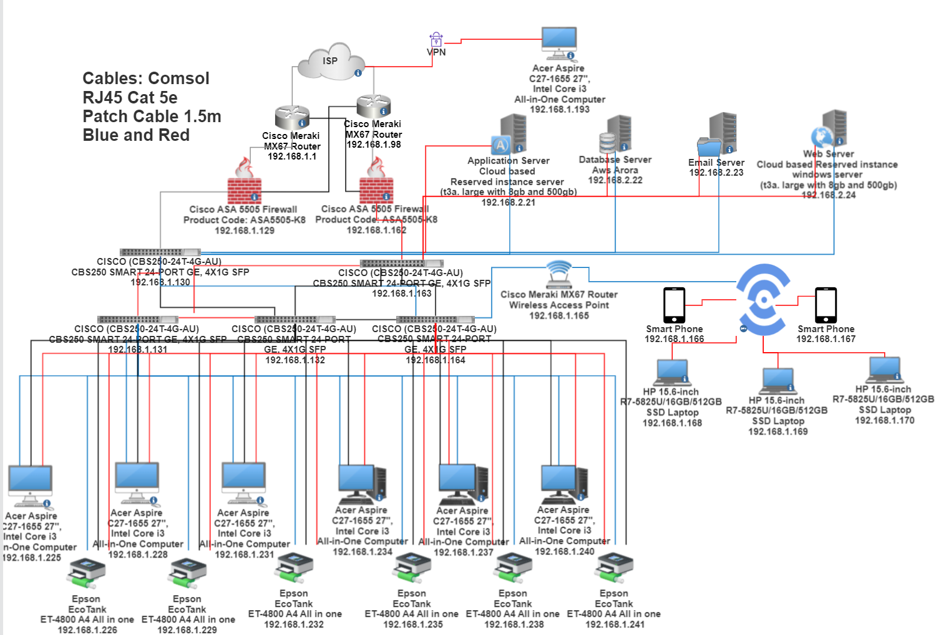

Figure : Physical Design Diagram

# The table of networking & communication devices and applications required, including the cost of each of them, the IP addresses, the product numbers as well as the approximate total cost:

## **Total Costing:**

The total cost of the project includes all the Network/ Communication devices listed above like laptops, Desktops, Printers, Routers, Switches, Application Server, Web Server, Database Server, cables, and Firewall is $12180 AUD will include all the network design cost.

# Explanation and justification of the networking & communication devices and applications required:

* The networking and communication devices listed above is needed for the business operations of SF cooperative society. This section gives the details information and explanation about the devices used and its corresponding needs in the business operation and in network design.
* Router: Starting with the Router there are two routers used which is an essential network component/device to receive the data and distributing it to the various hosts/users connected to it. Also, it will receive the data from outside world from the customer end and from the cloud service provider.
* Switches: There are four switches are used to distribute the data packets and it connected with the router and other devices in the network. The two switches are used to provide the resiliency to the SF network.
* Cables: The cables are used to connect the routers to switches, switches to desktop, printers to switches, etc. for the internal connectivity of the organization where the wireless functionality is not needed.
* Web, Application and Database Server: These servers are deployed on the AWS Cloud with all upfront cost paid and these are the reserved instance for one year by keeping the SF budget constraints requirements (AWS is assumed as the cloud service provider) the database server is used for hosting the SF database. There web server is used to server the clients who are using the website and need to establish the communication with the SF we interface. The Application server satisfies the customer requirements for the application interface. The database server is configured for receiving the data from the IoT devices as well.
* Printers: Two Printers are used to satisfy the printing requirements in the SF Rockhampton office.
* Desktops and Laptops: The desktops and laptops are required for the business operation without this nothing not possible to run their business. Here, five desktops and laptops are used respectively as in the Rockhampton office staff members are working.
* Firewall: The firewall devices is very important in this business to keep the data security and privacy for the outside world and the attackers.
* VPN connection: The VPN connection is needed for the SF people who are working outside the office and intended to access the SF servers.
* Operating System: The operating system is necessary to run the desktop system to conduct the business operation.
* Microsoft Office 365: This software is useful to for the staff members to do the office works (for making documents, etc.)

## Test Plan to test newly designed network:

Testing is a very important part of the any project before it is made live for the business operation usage. And to make a project testing there are many important steps and procedure that needs to be followed to make it standardized as per the industry testing services, by using the third-party systems and tools, and by building and testing the prototype system. There are mainly five components of the test plans which are:

* Test objective and acceptance criteria needs to be decided.
* What are the Types of tests that will run or processed
* Network equipment’s and other resources required for the testing
* Test scripts
* Timeline and milestones for the project testing

## Test objective and Acceptance criteria:

There are specific and concrete test cases needs to be developed and tested so find whether the given and decided business goals are achieved by making this system design for the SF cooperative society. Also, the criteria need to be decided for example the customer can put the order online and the website or app is easily accessible when it is deployed on the network. If it is not done, then refer the business goals again.

## Types of tests need to be done:

There are mainly four types of tests are there that needs to be done to do testing with the network technical design perspective:

* **Application response time testing** needs to be done to check the deployed website or apps deployed on the server which is serving in how much time to the requested user. There are many tools available to make this testing (like Website monitoring using uptrends).
* **Throughput tests** is done to check the network performance that the given network is not facing any bottleneck at the time of data transmission.
* **Availability Testing** need to be done to check the website or app availability on network by creating a bottleneck, increasing load or DDoS attack to test the backup server and current server.
* **Regression testing** is done to check the core functionality of the SF network is not change which doing any changes in the network or while updating the network.

## Network equipment’s and resources required for the testing:

In this section of the testing the network design is tested using the Network virtual environment like using the Cisco packet tracer or using other network simulation or modeling equipment or tools. Also, it can be done by implementing the design at the customer site for the testing with the help of the SF staff members in the networking suitable environment like in the A.C. room and with the other requirements.

## Testing done using Test Script:

In this the test script is written for the network test case like to check that firewall is working properly or not on this on script needs to be prepared and as per the steps decided the testing should be done.

## Timeline and milestones for the project testing:

In this the timeline is decide after the specific time interval the testing is done and it should be passes if it performs the specific business goals requirements are satisfied and up to the specific time interval.

## Detail Test plan script:

One detail test plan script is to be done to test that the firewall is blocking SF proprietary application traffic in the light, moderate and in the heavy traffic load is experienced by the network. The test is only gets accepted when the firewall blocks all the traffic containing TCP SYN packets from the customer network and going to the database server and it should send the TCP RST (reset) packets to the webserver (Openheimer, P.et al, 2011).

Network 2

Network 1

1. First start to capture the network traffic on the protocol analyzer on Customer Side Network1.
2. Now start to capture the traffic network on the protocol analyzer on Network 2 (database server).
3. Run SF Application on a Customer Side Network that is outside the organization located on Network 1 and access database on Network 2.
4. Stop capturing network traffic on the protocol analyzers.
5. Display data on Network 1 protocol analyzer and verify that the analyzer captured a TCP SYN packet from the workstation. Verify that the network layer destination addresses of database server on Network 2, and the destination port is port 3551 (the port number for SF Application). Verify that the firewall responded to the workstation with a TCP RST packet.
6. Display data on Network 2 protocol analyzer and verify that the analyzer did not capture any SF Application traffic from the web server
7. Log the results of the test in the project log file.
8. Save the protocol-analyzer traced files to the project trace-file directory/folder.
9. Gradually increase the workload on the firewall, by increasing the number of requests on Database Server deployed on the Network 2 one at a time, until it sends 50 requests on the running SF database application. Repeat steps 1 through 8 after each workstation is added to the test(Openheimer, P.et al, 2011).

# Recommendation:

In the recommendation I would like to say two things that if the SF cooperative get a chance to increase the budget and to update the design then I would like to suggest the hybrid design so that some servers can be deployed on-site and some on the cloud based so they can be able to manage the business operation more securely and they can also increase more resiliency. Also, if they increase the budget then they can get the 24/7 internet connectivity with downtime which is quite impossible due to the budget constraints.

# Conclusion:

To conclude, we have tried to achieve and implement all the business goals successfully as per the demand done by the SF cooperative society to design network for them so they can conduct and run their business operation at ease and with the greater efficiency. Using the top-down network design methodology and the logical and physical diagrams are prepared. Also, as per the diagram the network installation will be easy to do because the report gives all the information above the users who will use this system and how will use. The security mechanisms and test plans are given with the detail description to it will be easier for the other network engineers to test the network load easily when the SF will face any difficulties.

# References:

Angelino, A. et al. (2021) Institutional and economic transition in Vietnam: Analysing the heterogeneity in firms’ perceptions of business environment constraints. Competition & change. [Online] 25 (1), 52–72.

Geier, J., 2015. Designing and deploying 802.11 wireless networks: a practical guide to implementing 802.11 n and 802.11 ac wireless networks for enterprise-based applications. Cisco Press.(<https://cqu-a.alma.exlibrisgroup.com/leganto/readinglist/lists/10312133640003441?institute=61CQU_INST&auth=SAML>).

Oppenheimer, P. et al. (2011) Top-down network design. Third edition. Indianapolis, Ind: Cisco Press.